Create And Configure IBM Cloud Service Create A Database in Cloudant DB

|  |  |
| --- | --- |
| **Date** | **29 October 2022** |
| **Team ID** | PNT2022TMID40586 |
| **Project Name** | **loT Based Industry Specific Intelligent Fire Management System** |
| **Maximum Marks** | **4 Marks** |

# AIM

To create a database in Cloudant DB to store location data

# STEPS

1. Login to IBM Cloud with smart internet mail ID and Password.

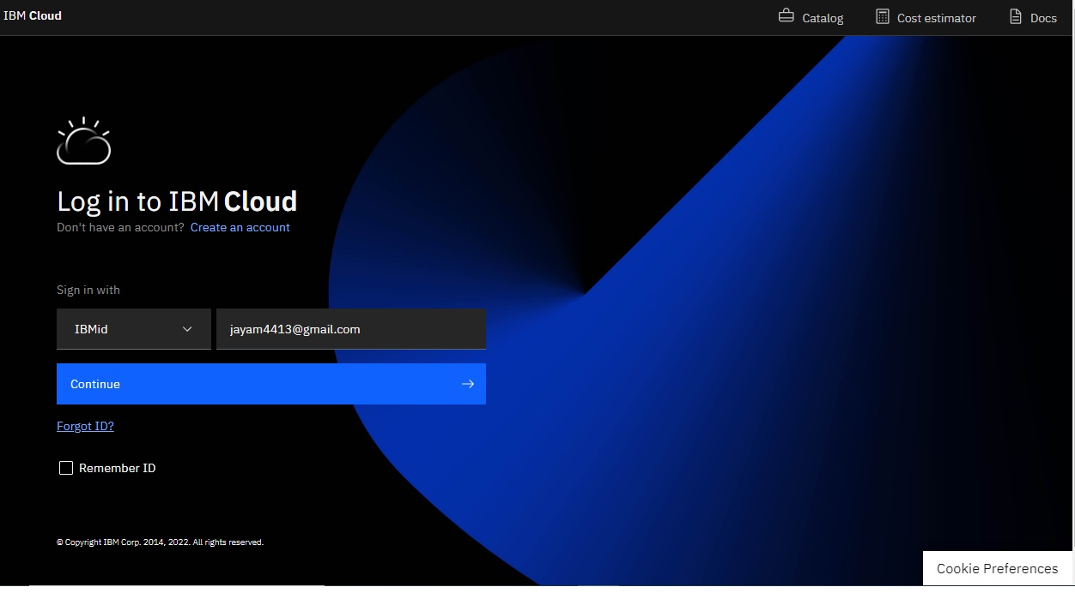

1. 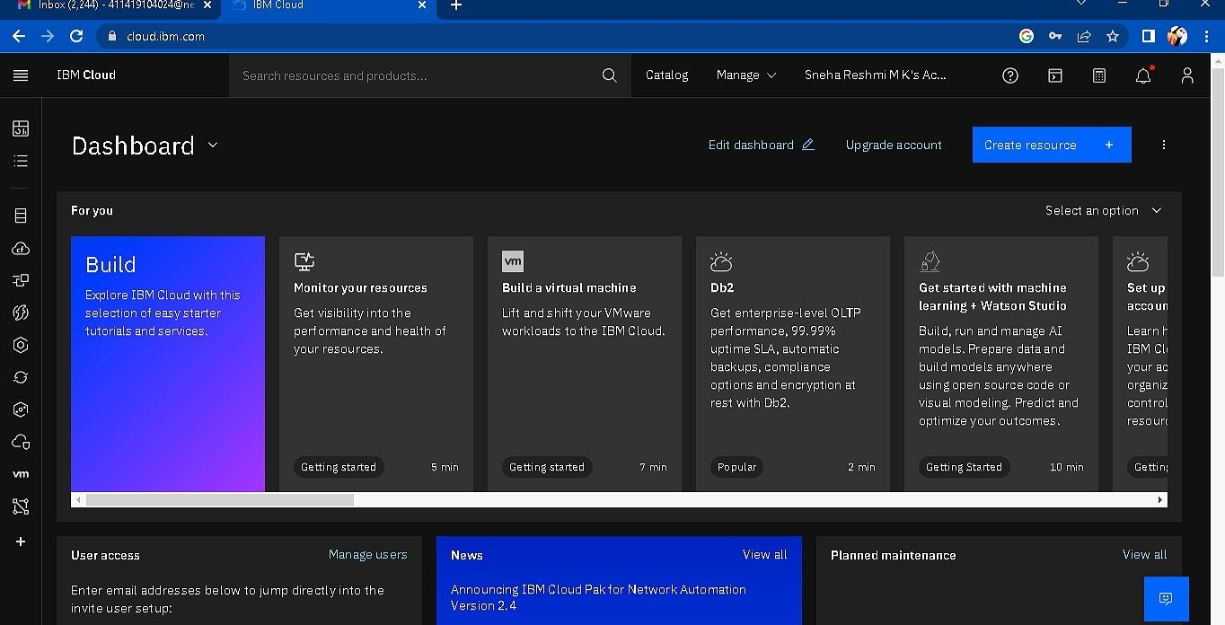Click “Create Resource +” button
2. 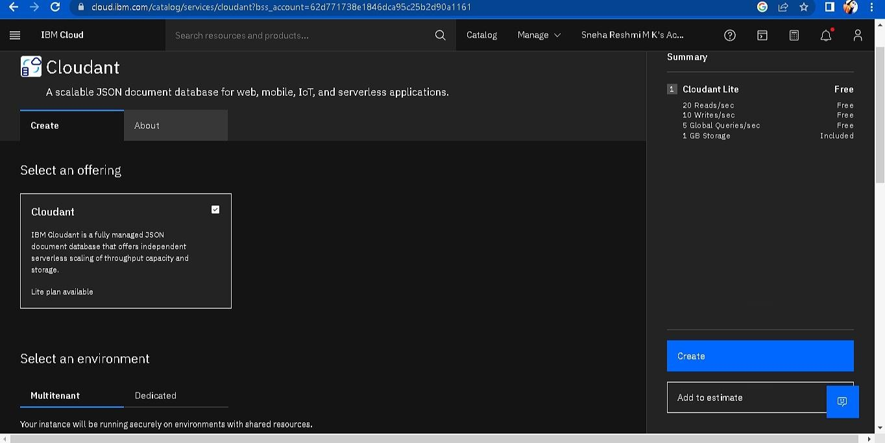Search Cloudant in Catalog then Choose the Lite version

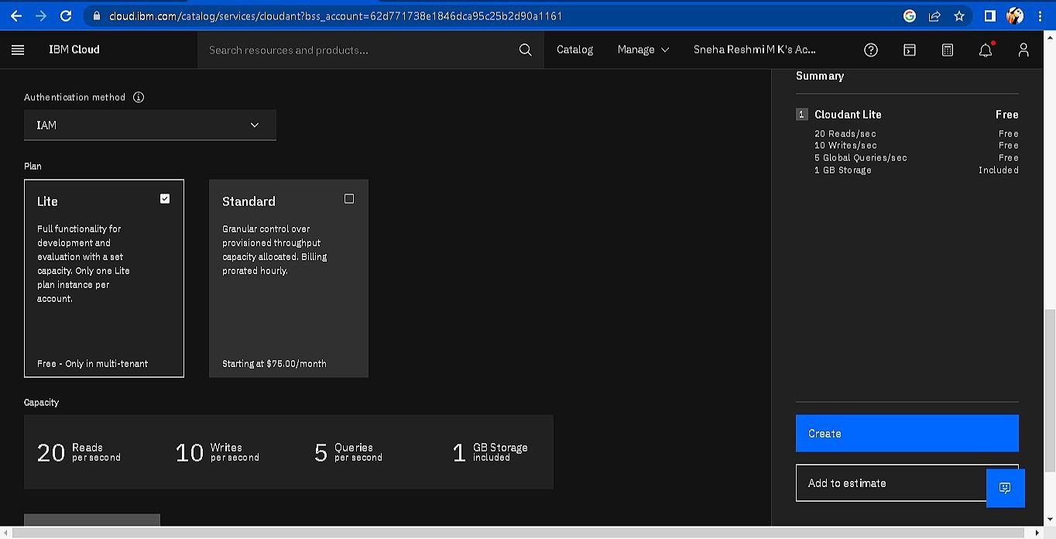

1. 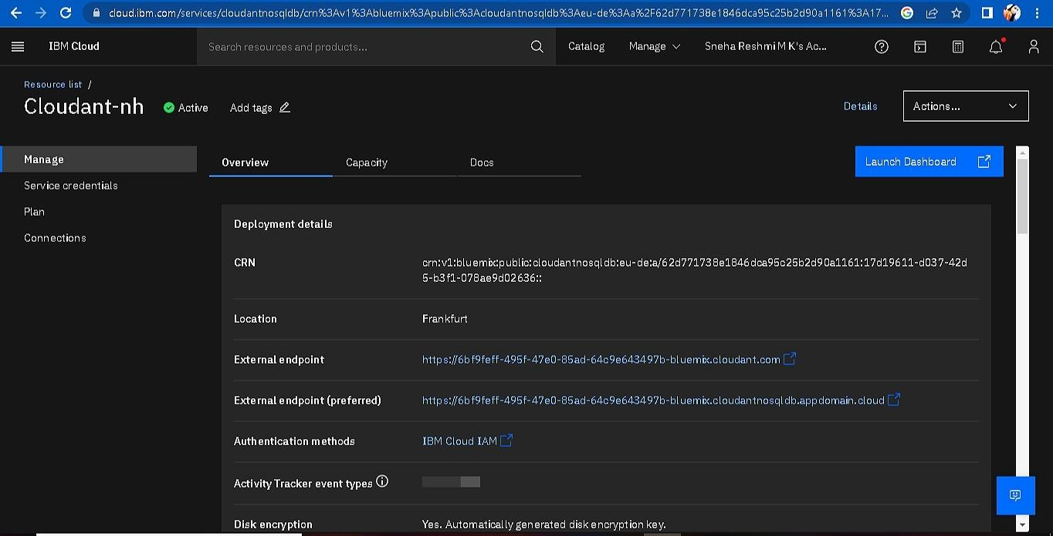The Cloudant database resource created
2. click on launch dashboard

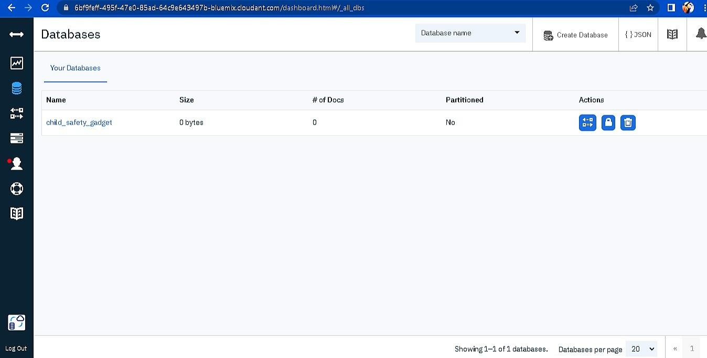

1. Click “Create Database”. Entered “Fire Safety_Device” as the database name and the “Non-partitioned” option.
2. The database “Fire Safety Device” has been created and it's work Successfully

# RESULT:

A database to store the location data on Cloudant DataBase has been created successfully.

TEAM ID: PNT2022TMID40586

TEAMLEADER: C.V.GOWSIKHA MEMBER 1: K.TAMILARASAN MEMBER 2: G.ARULRAJ MEMBER 3: S.KUMARESAN

MENTOR:R.ARUL ARUMUGAM